ISTE-230 Introduction to Database & Data Modeling

## Practice Exercise # 9 – Transposing

**Name:** Brian Zarzuela

**Problem #1**

Transpose the E-R diagram below into relations, implementing all relationships. Denote primary keys and foreign keys appropriately. Use proper relation notation. Make sure your relation names are in all caps.

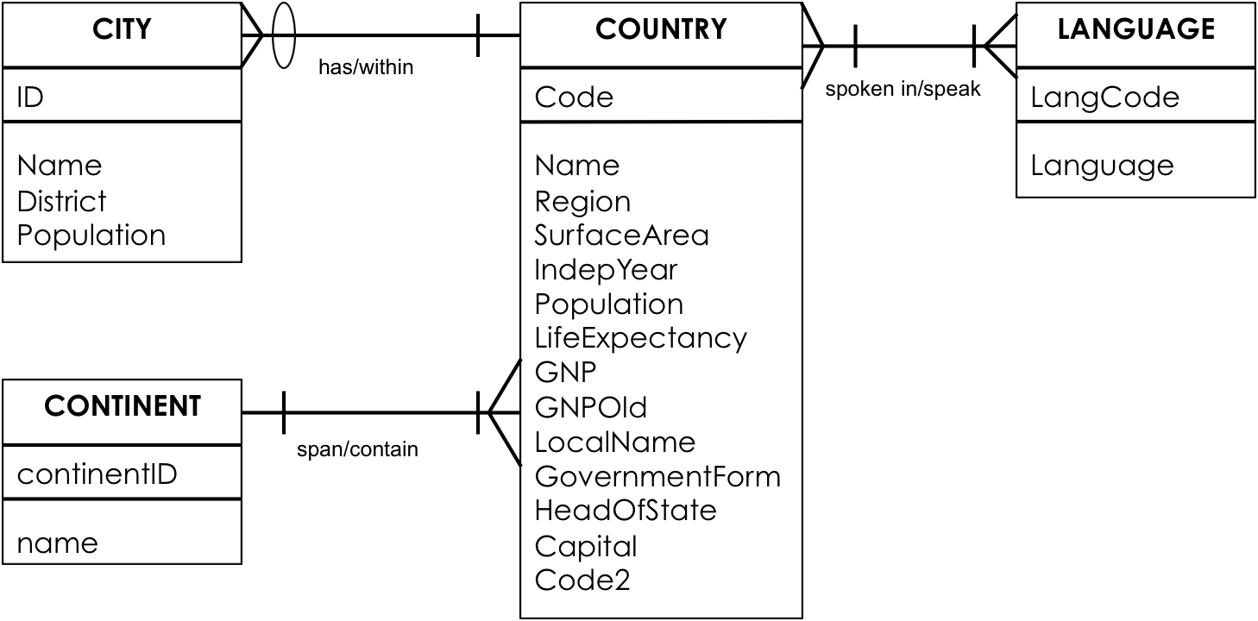

**YOUR TRANSPOSED RELATIONS:**

CITY(ID, *Code*, Name, District, Population)

CITY(Code) mei COUNTRY(Code)

CONTINENT(continentID, name)

COUNTRY(Code, *continentID*, Name, Region, SurfaceArea, IndepYear, Population, LifeExpectancy, GNP, GNPOld, LocalName, GovernmentForm, HeadOfState, Capital, Code2)

COUNTRY(continentID) mei CONTINENT(continentID)

LANGUAGE(LangCode, Language)

COUNTRY_LANGUAGE(*Code, LangCode*)

COUNTRY_LANGUAGE(Code) mei COUNTRY(Code)

COUNTRY_LANGUAGE(LangCode) mei LANGUAGE(LangCode)

**Problem #2**

Transpose the E-R diagram below into relations, implementing all relationships. Denote primary keys and foreign keys appropriately. Use proper relation notation. You do not need to fix any possible normalization issues.

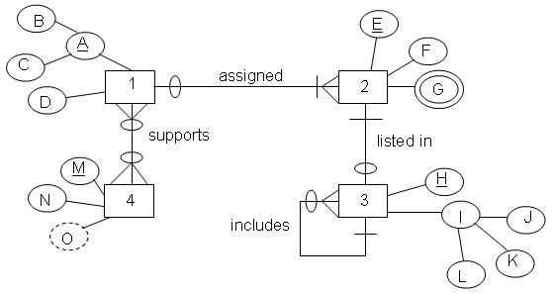

**YOUR TRANSPOSED RELATIONS:**

1(B, C, D)

2(E, F, G, *B, C*)

2(B, C) mei 1(B, C)

3(H, J, K, L, *E, includes*)

3(E) mei 2(E)

3(includes) mei 3(H)

4(M, N)

1_4(*B, C, M*)

1_4(B, C) mei 1(B, C)

1_4(M) mei 4(M)

**Problem #3**

Transpose the E-R diagram below into relations, implementing all relationships. Denote primary keys and foreign keys appropriately. Use proper relation notation. Make sure your relation names are in all caps.

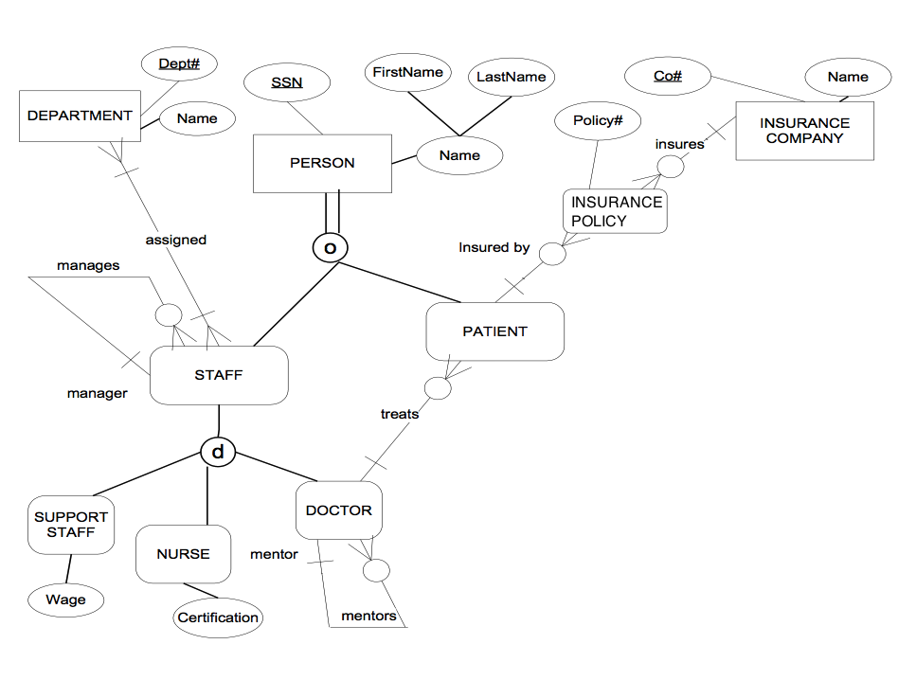

**YOUR TRANSPOSED RELATIONS:**

PERSON(SSN, FirstName, LastName)

PATIENT(*SSN, DoctorSSN*)

PATIENT(SSN) mei PERSON(SSN)

PATIENT(DoctorSSN) mei DOCTOR(SSN)

STAFF(*SSN, ManagerSSN*)

STAFF(SSN) mei PERSON(SSN)

STAFF(ManagerSSN) mei STAFF(SSN)

DOCTOR(*SSN*, *MentorSSN*)

DOCTOR(SSN) mei STAFF(SSN)

DOCTOR(MentorSSN) mei DOCTOR(SSN)

SUPPORT_STAFF(*SSN*, Wage)

SUPPORT_STAFF(SSN) mei STAFF(SSN)

NURSE(*SSN*, Certification)

NURSE(SSN) mei STAFF(SSN)

DEPARTMENT(Dept#U, Name)

INSURANCE_COMPANY(Co#, Name)

INSURANCE_POLICY(Policy#, *Co#, PatientSSN*)

INSURSANCE_POLICY(Co#) mei INSURANCE_COMPANY(Co#)

INSURANCE_POLICY(PatientSSN) mei PATIENT(SSN)

DEPARTMENT_STAFF(*Dept#, StaffSSN*)

DEPARTMENT_STAFF(Dept#) mei DEPARTMENT(Dept#)

DEPARTMENT_STAFF(StaffSSN) mei STAFF(SSN)